EBS:
Linux Ec2 Instance Creation:
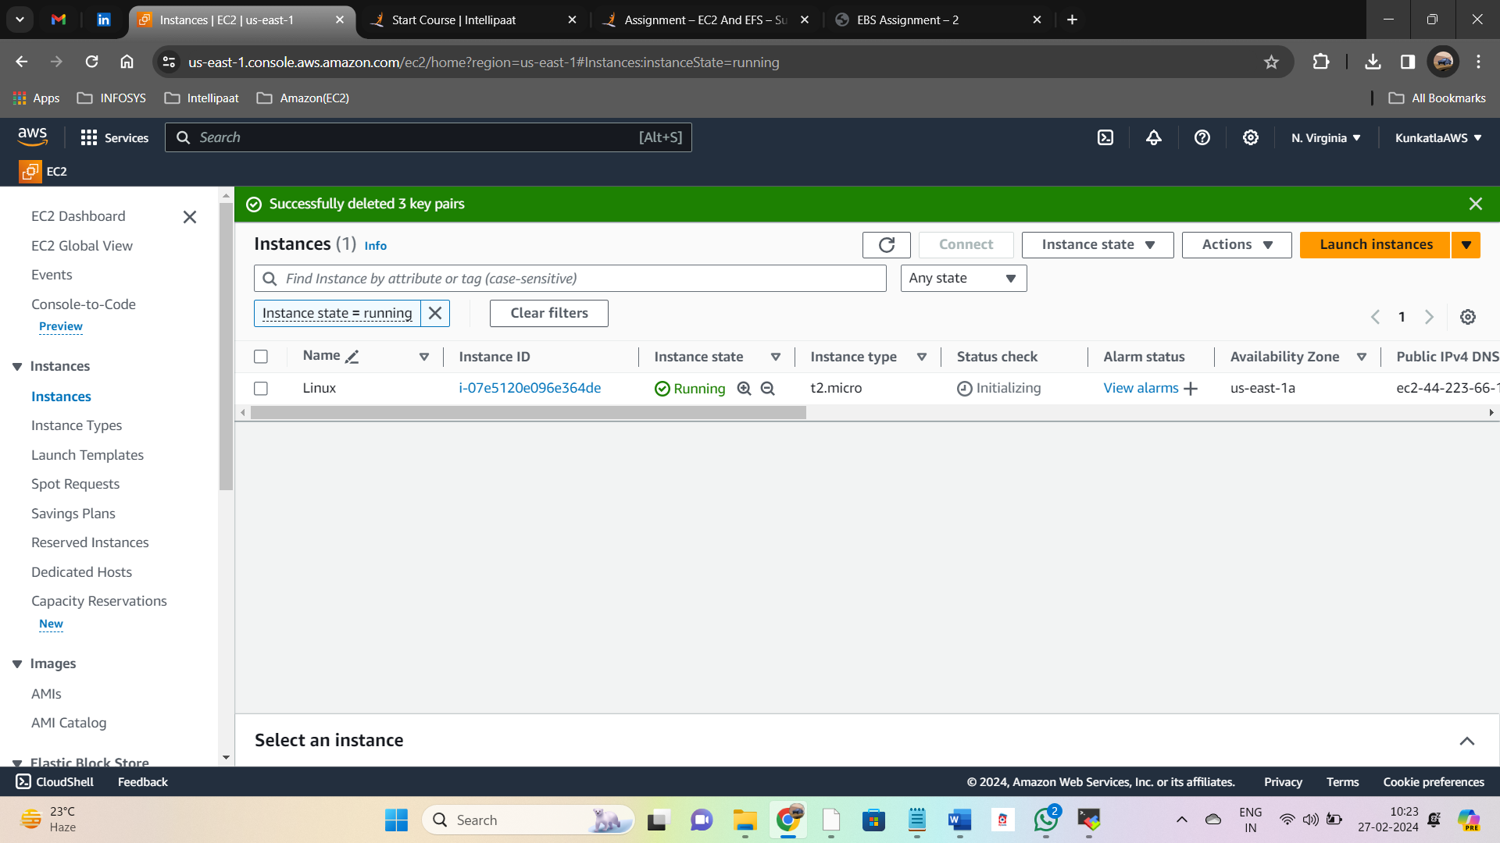

Created an EBS volume with 20 GB of storage
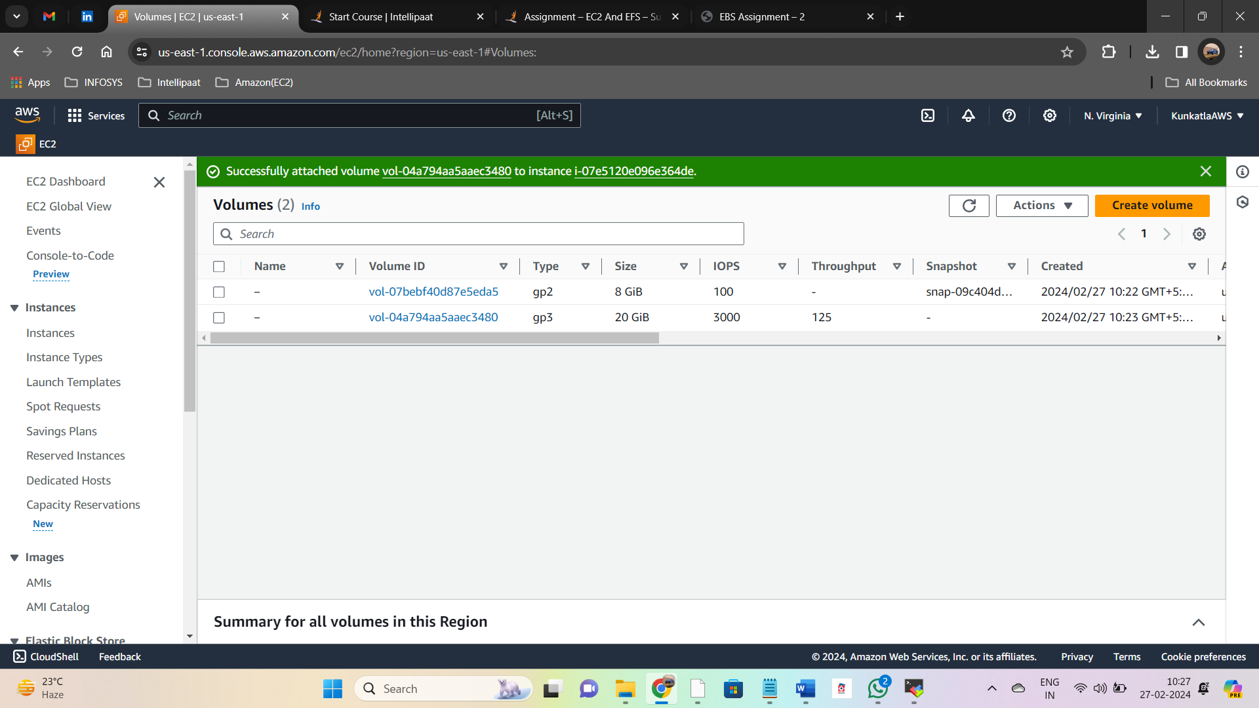

Attach EBS volume to the created EC2 instance:
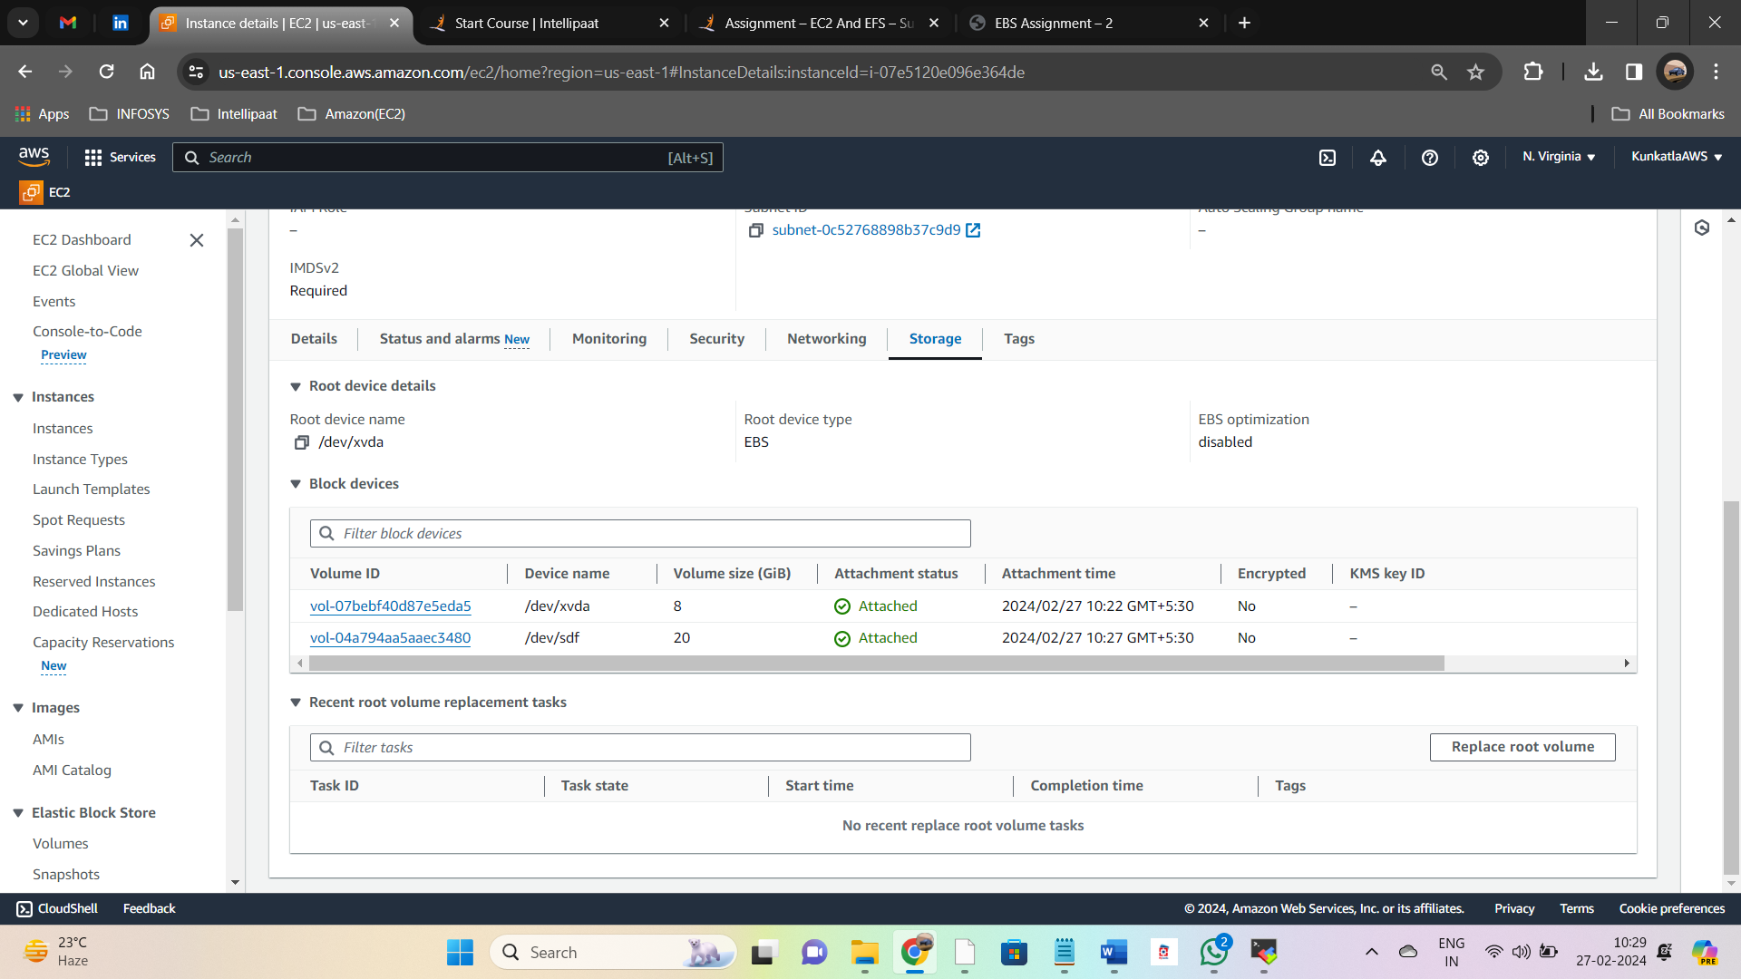

Requested volume modification for volume vol-04a794aa5aaec3480:
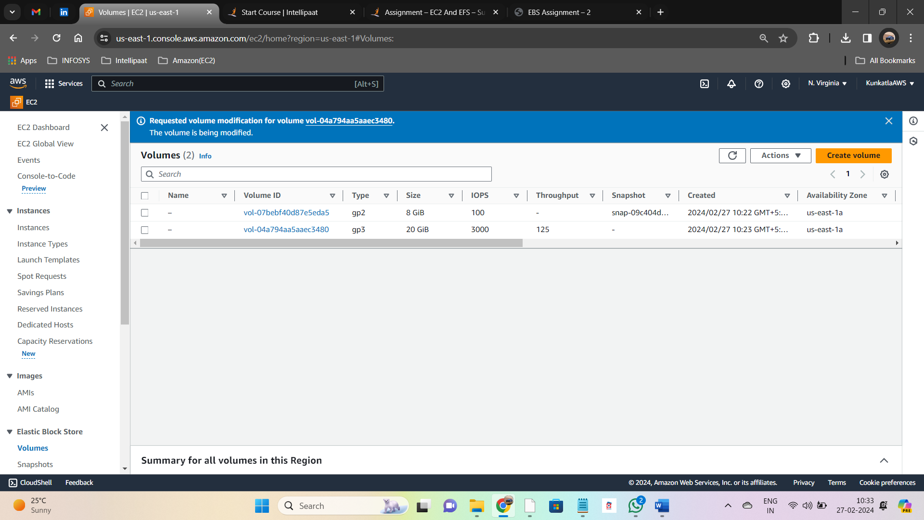

Modified Volume 25GB reflects in the Linux Instance:
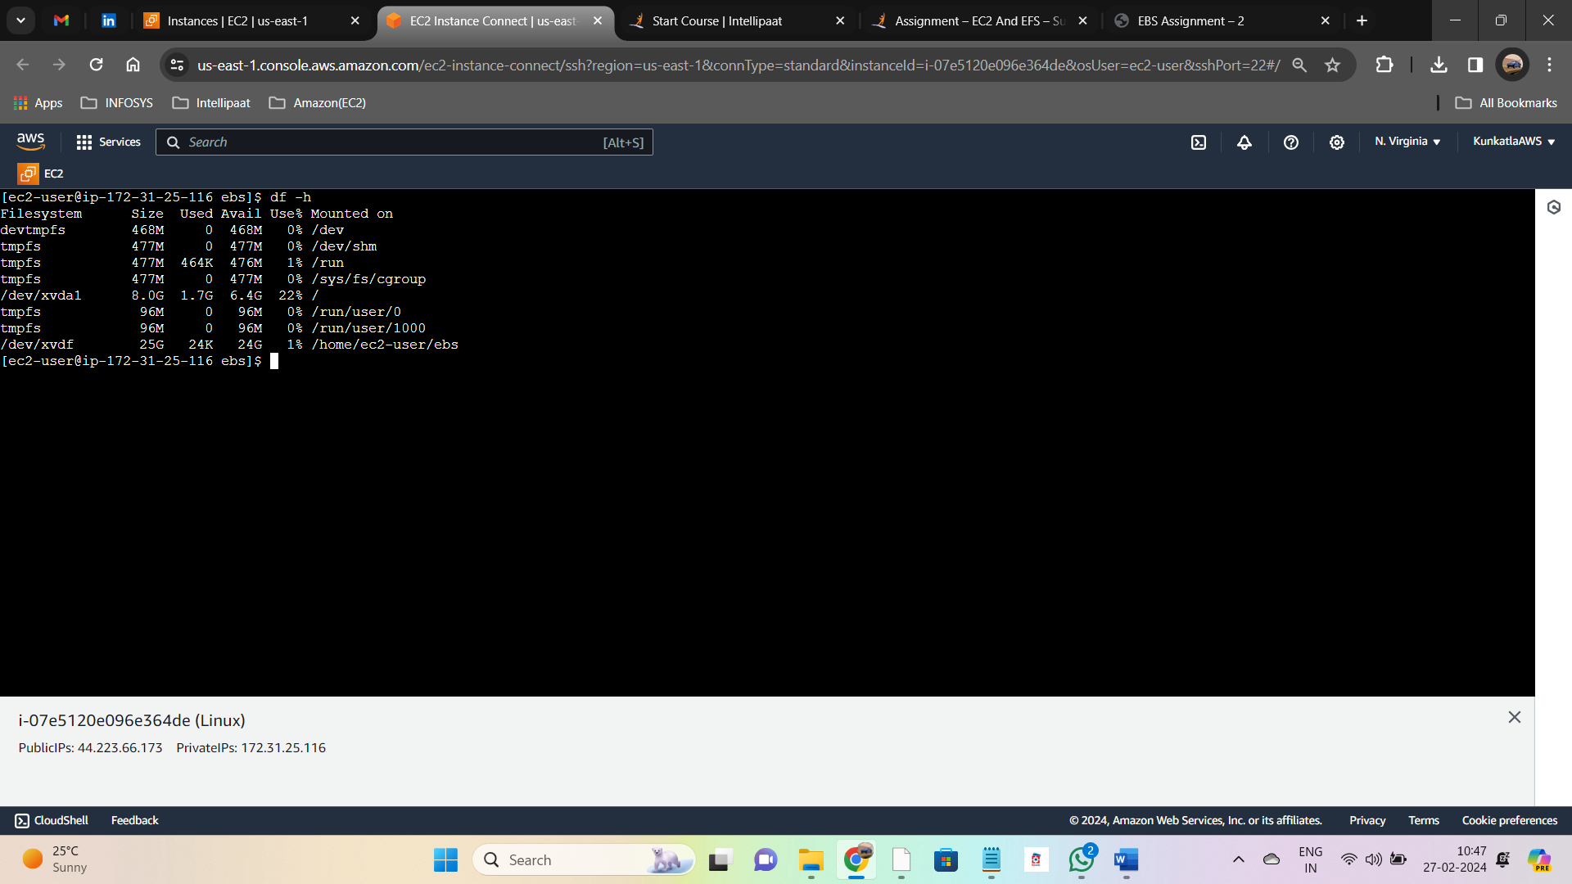

EFS:
Amazon Elastic File System (EFS) Creation:
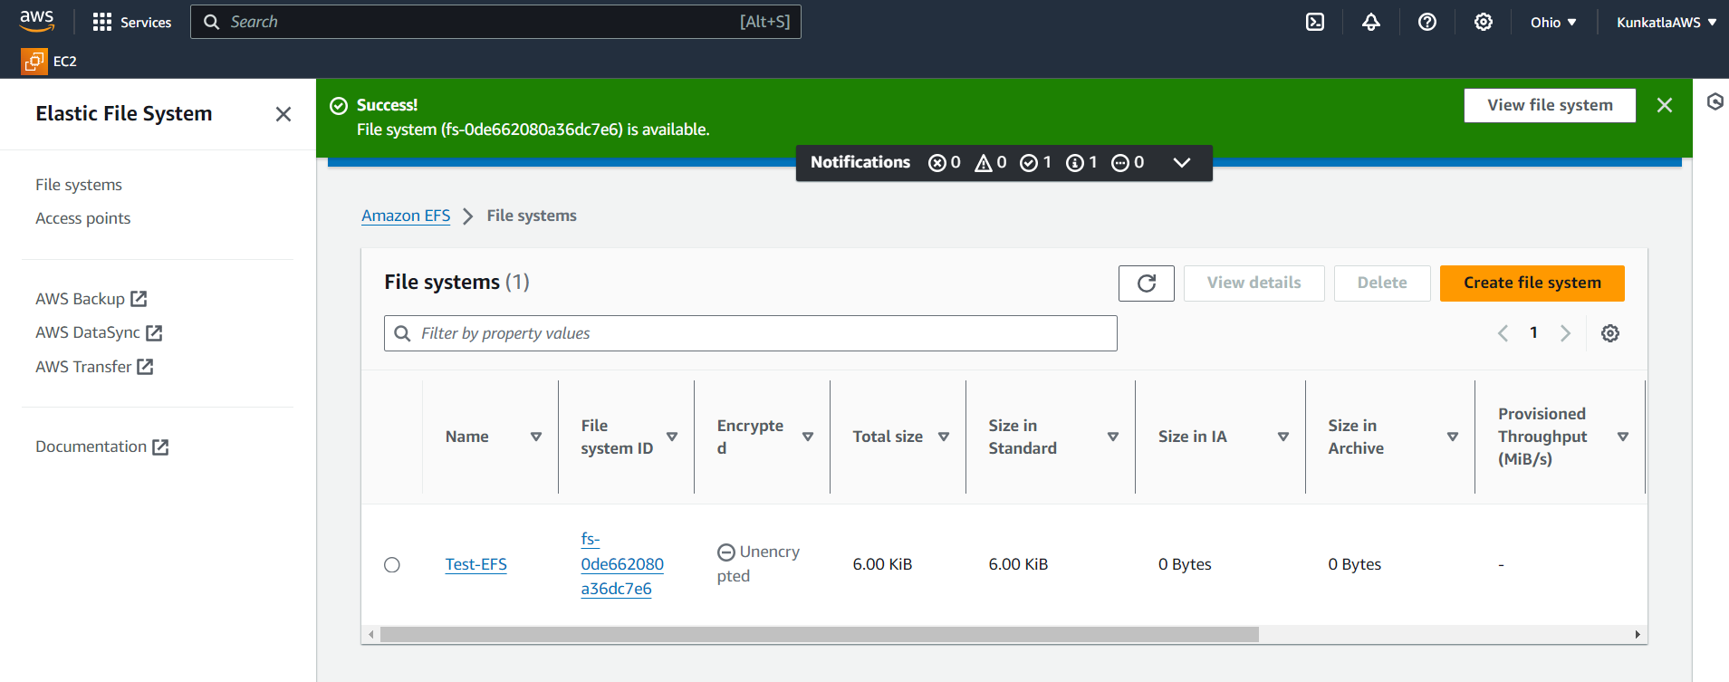

Inbound Security group rules successfully modified:
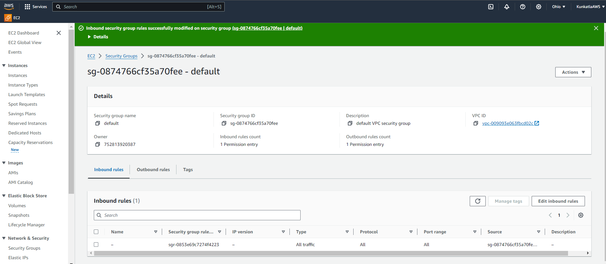

Multiple EC2 Instances Creation:
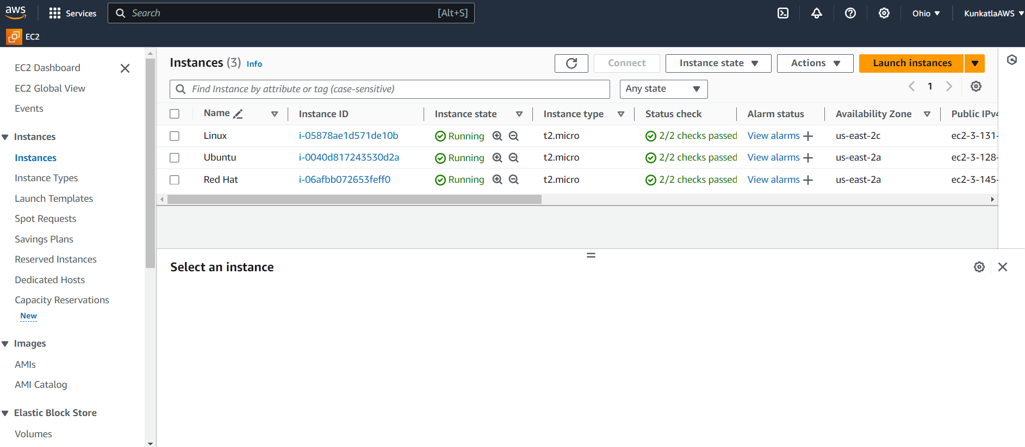

Linux Server mounted with EFS:
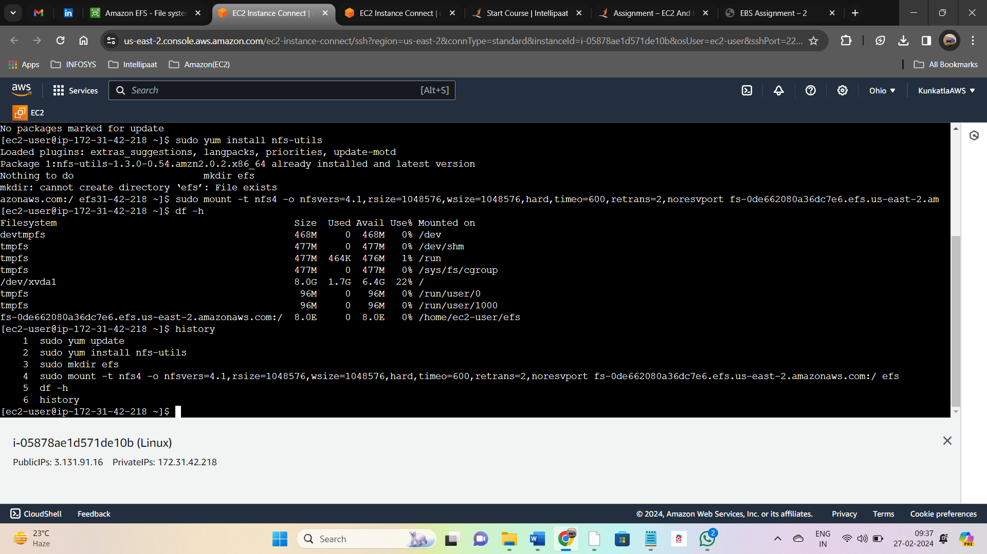

Ubuntu server mounted with EFS:
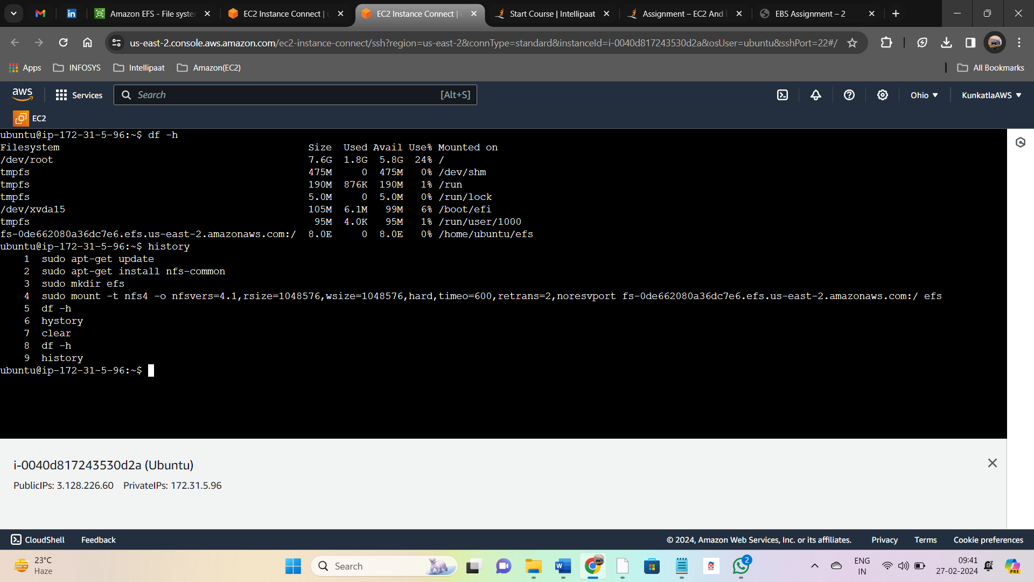

Red Hat server mounted with EFS:
